**The IEEE European Low Voltage Test Feeder**

May 19, 2015

# I. Objective

The Test Feeders Working Group of the Distribution System Analysis Subcommittee of the Power Systems Analysis, Computing, and Economics (PSACE) Committee has published several test feeders [1] and released a roadmap for high-priority development of new test cases [2]. The current test cases are focused on North American style systems and provide only static power flow results. The purpose of this test feeder is to provide a benchmark for researchers who want to study low voltage feeders, which are common in Europe, and their mid- to long-term dynamic behaviors. Time-series power flow solutions for this test feeder are provided using OpenDSS [3] and GridLAB-D [4].

# II. Introduction

The current test cases are focused on North American style systems; however it is common outside of North America to see low-voltage distribution systems, both radial and meshed. It is important to make sure that tools support both dominant styles of distribution system configuration. This test case seeks to fill a benchmark gap by presenting a number of common low-voltage configurations.

In distribution research and planning, it is becoming more readily apparent that time-series solutions, rather than static power flow solutions, are required to capture the mid- to long-term dynamic behavior evident in many technologies. Proper evaluation of products or concepts such as Volt Var Optimization (VVO), coordinated regulator and capacitor controls, energy storage, or photovoltaic requires an element of time to truly understand the behavior.

The European low voltage test case was developed to meet the needs, which has the following features:

1. The test feeder is at the voltage level of 416 V (phase-to-phase), which is typical in the European low voltage distribution systems.
2. Load shapes with a one-minute time resolution over 24 hours are provided for time-series simulation.
3. Time-series simulation results over a one-day period and static power flow calculation results at some key moments are provided.

# III. The Case Description

The low voltage test feeder is a radial distribution feeder with a base frequency of 50 Hz. The feeder is connected to the medium voltage (MV) system through a transformer at substation. The transformer steps the voltage down from 11 kV to 416 V. The main feeder and laterals are at the voltage level of 416 V. The one-line diagram of the test feeder is shown in Fig. 1. The bus coordinates are given in the *Buscoords.csv* file.

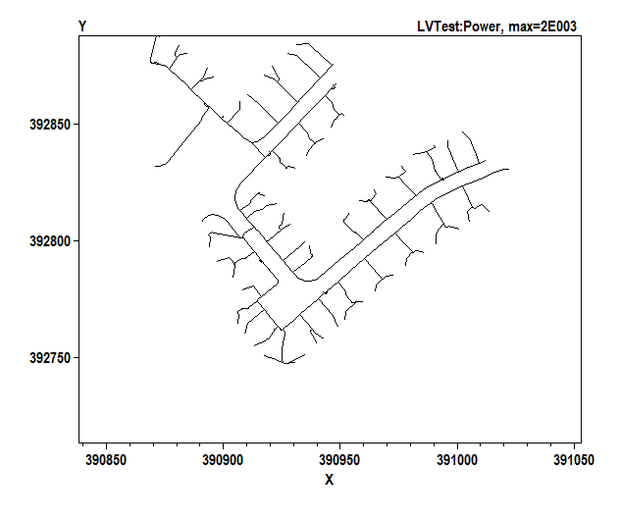

**Substation**

***Fig. 1. One-line diagram of the European low voltage test feeder.***

The MV system is modeled as a voltage source with an impedance. The data for the source is given in the *Source.csv* file. The impedance is specified by short circuit currents.

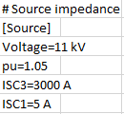

Impedance is specified by three-phase and single-phase short circuit currents.

The three-phase transformer at substation has a rated MVA of 0.8, rated voltages of 11/.416 kV, and a delta/grounded-wye connection. The resistance and reactance of the windings are 0.4% and 4% (use the kVA and kV base of the high-voltage winding), respectively. The data for transformer is given in the *Transformer.csv* file.

Distribution lines are defined by line codes and their length. Line codes are specified by sequence impedances and admittances. The data for lines and line codes are given in the *Lines.csv* and *lineCodes.csv* files, respectively.



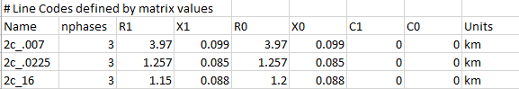

Ohms, Series Impedance form

nF, Nodal Admittance form

Loads are modeled as constant PQ ones. For each load, the base load is specified using kW and power factor (PF). Load shapes are also defined for time-series simulation. Data for loads and load shapes are given in the *Loads.csv* and *LoadShapes.csv* files.

Load Shapes

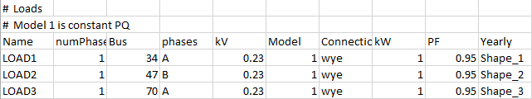

Each load shape is linked to a .csv file that defines the load profile.

Load Profiles

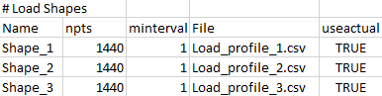

Load profiles are defined by a matrix with two columns. The first column specifies the time, while the second column specifies the multiplier values. A portion of the *Load_profile_1.csv* file is shown below.

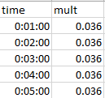

Multiplier Values

The kW value of a load at a specific time is determined by its base kW and multiplier values. Take LOAD1 as an example, its base kW value is 1 and the value of multiplier at time 00:01:00 is 0.036. Therefore, the kW value of LOAD1 at time 00:01:00 is 1 $×$ 0.036=0.036.

# IV. Results

**1. Time-series simulation**

Time-series load shapes for the 55 loads served by the test feeder are provided with a one-minute time resolution over a one-day period. Time-series simulations are performed using OpenDSS and GridLAB-D, respectively. The curves of the active and reactive power at the substation over 24 hours (1440 minutes) are shown in Fig. 2(a). The magnitude of voltage at LOAD1 (phase A), LOAD32 (phase C), and LOAD53 (phase B) over the one-day period are shown in Fig 2(b). Results provided by OpenDSS and GridLAB-D are compared, the differences between them are shown in Table I and Fig 2.

***Table I***

***Maximum differences in time-series simulation results from OpenDSS and GridLAB-D***

|  |  |  |  |  |  |  |
| --- | --- | --- | --- | --- | --- | --- |
| **Variable** | $$P_{a}$$ | $$Q_{a}$$ | $$P_{b}$$ | $$Q_{b}$$ | $$P_{c}$$ | $$Q_{c}$$ |
| **Difference (%)** | 0.0435 | 0.2080 | 0.1006 | 0.1121 | 0.0639 | 0.1013 |
| **Variable** | $$P_{3ϕ}$$ | $$Q_{3ϕ}$$ | $$V_{load1}$$ | $$V_{load32}$$ | $$V_{load53}$$ |  |
| **Difference (%)** | 0.0176 | 0.0126 | $$4.6×{10}^{-4}$$ | $$7.9×{10}^{-4}$$ | $$7.6×{10}^{-4}$$ |  |





***Fig. 2. Time-series simulation results: (a) active and reactive power at substation and (b) load voltages.***

**2. Snapshot Simulation**

Snapshots of power flow at the following moments are captured:

* time = 00:01:00, i.e., the initialization of the simulation, as well as the off-peak moment,
* time = 09:26:00, i.e., the on-peak moment, and
* time = 24:00:00, i.e., the end of the simulation.

The active and reactive power at the substation at the three moments are shown in Table II. The maximum and minimum voltages are shown in Table III. Results from OpenDSS and GridLAB-D are provided.

***Table II***

***Active and Reactive Power at Substation – Snapshot Simulation Results***

|  |  |  |  |  |  |  |
| --- | --- | --- | --- | --- | --- | --- |
| Time |  |  | Phase A | Phase B | Phase C | Total |
| 00:01:00  (off-peak) | Active Power  (kW) | OpenDSS | 1.0572 | 0.927 | 0.8153 | 2.7994 |
| GridLAB-D | 1.0569 | 0.9266 | 0.8154 | 2.7989 |
| Reactive Power (kVar) | OpenDSS | 0.3475 | 0.3044 | 0.2678 | 0.9198 |
| GridLAB-D | 0.3472 | 0.3046 | 0.2679 | 0.9197 |
| 09:26:00  (on-peak) | Active Power  (kW) | OpenDSS | 17.9072 | 35.2927 | 6.1837 | 59.3836 |
| GridLAB-D | 17.9067 | 35.2935 | 6.1837 | 59.384 |
| Reactive Power (kVar) | OpenDSS | 5.4897 | 11.5328 | 2.0971 | 19.1196 |
| GridLAB-D | 5.4895 | 11.533 | 2.097 | 19.1195 |
| 24:00:00 | Active Power  (kW) | OpenDSS | 3.7201 | 3.6648 | 2.3369 | 9.7218 |
| GridLAB-D | 3.7201 | 3.6649 | 2.3368 | 9.7218 |
| Reactive Power (kVar) | OpenDSS | 1.2189 | 1.2048 | 0.7678 | 3.1914 |
| GridLAB-D | 1.2189 | 1.2047 | 0.7677 | 3.1914 |

***Table III***

***Maximum and Minimum Bus Voltages – Snapshot Simulation Results***

|  |  |  |  |  |  |
| --- | --- | --- | --- | --- | --- |
| Time |  |  | Phase A | Phase B | Phase C |
| 00:01:00  (off-peak) | Max Voltage  (V) | OpenDSS | 252.165 | 252.166 | 252.169 |
| GridLAB-D | 252.1647 | 252.166 | 252.1691 |
| Min Voltage  (V) | OpenDSS | 251.909 | 251.946 | 252.023 |
| GridLAB-D | 251.9092 | 251.9464 | 252.0229 |
| 09:26:00  (on-peak) | Max Voltage  (V) | OpenDSS | 251.901 | 251.443 | 254.73 |
| GridLAB-D | 251.9008 | 251.4426 | 254.7302 |
| Min Voltage  (V) | OpenDSS | 245.577 | 238.367 | 251.952 |
| GridLAB-D | 245.5769 | 238.3686 | 251.9521 |
| 24:00:00 | Max Voltage  (V) | OpenDSS | 252.113 | 252.105 | 252.134 |
| GridLAB-D | 252.1126 | 252.1051 | 252.1336 |
| Min Voltage  (V) | OpenDSS | 251.08 | 251.109 | 251.805 |
| GridLAB-D | 251.0798 | 251.1091 | 251.8049 |

Detail results can be found in the *Solutions* folder.

# Reference:

[1] IEEE PES Distribution Systems Analysis Subcommittee Radial Test Feeders [Online], Available: http://ewh.ieee.org/soc/pes/dsacom/testfeeders.html.

[2] R. C. Dugan, W. H. Kersting, S. Carneiro, R. F. Arritt, and T. E. McDermott, "Roadmap for the IEEE PES test feeders," *IEEE Power Systems Conference and Exposition*, pp.1-4, March 2009.

[3] Electric Power Research Institute, OpenDSS, Distribution System Simulator [Online], Available: http://sourceforge.net/projects/electricdss/.

[4] U.S. Department of Energy at Pacific Northwest National Laboratory, GridLAB-D, Power Distribution Simulation Software [Online]. Available: http://www.gridlabd.org/.